EdTA Festival Main Stage Adjudication Training

Adjudication Training Sample Scoring
SHOW – She Stoops to Conquer

Adjudicator Name ___________________________________

Adjudicator Email ___________________________________

Use Characterization and 1 of the other 4 categories (Blocking, Vocal Quality, Costumes & Set) to score and comment on. When you are finished, email this completed form to mzortman@gmail.com.

You should use a minimum of 75 words as your guide of how much to write.

Remember, your comments should...
- Justify your scoring
- Be able to be shared with students, staff and administrators
- Address the valued rubric which address learning opportunities

Your comments should avoid...
• Absolute terms such as NEVER, ALWAYS and ALL THE TIME
• RIGHT or WRONG
• HATE
• SHOULD HAVE
• BAD or GOOD
• LOVE (without explanation)

CHARACTERIZATION
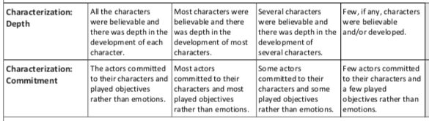
Score:

Comments:

BLOCKING
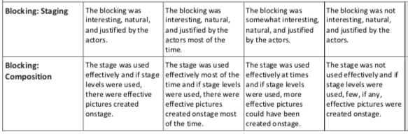
Score:

Comments:

VOCAL QUALITY
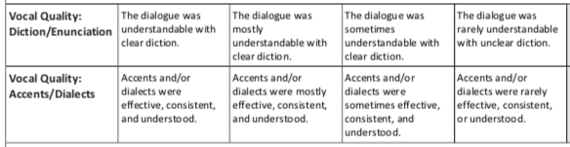
Score:

Comments:

COSTUMES
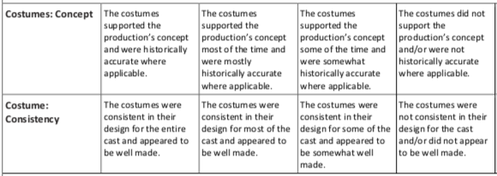
Score:

Comments:

SET
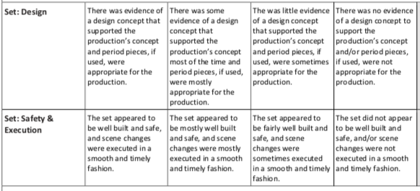
Score:

Comment:

