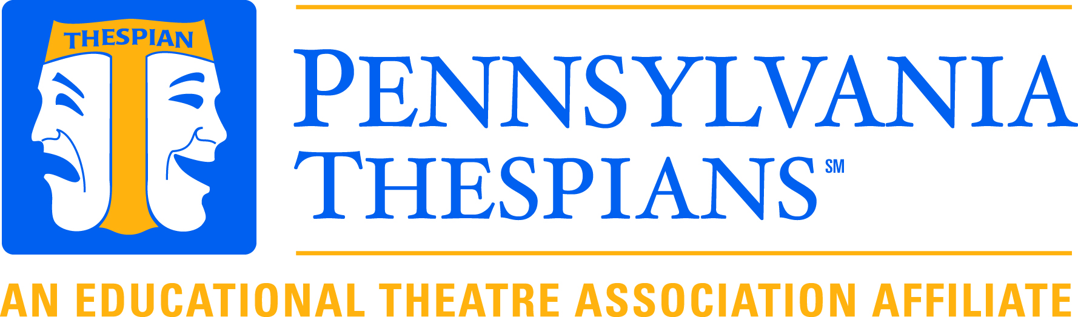
Mark Zortman, Chapter Director
3695 Crossfield Lane
York, PA 17406
mzortman@gmail.com

STO APPLICATION Signature page

Along with filling out the online STO application, you will need to have this form completed, signed by your parents and your troupe director, and upload on the online form.

I understand that if elected I will be expected to attend the STO State Board meetings and arrive on Wednesday evening prior to the conference for board preparation. If I am unable to attend a meeting, I will notify the State Board in a timely manner and do my best to communicate with the PA STO regularly.

NOTE: There is to be only one candidate per troupe. At the conference, all candidates will participate in the Student Leadership workshop. This workshop will be the process through which the new STO will be selected.

Student Name _________________________________

PARENTAL APPROVAL

I approve of my son/daughter’s candidacy for the State Thespian Board. I understand that there may be some traveling and expenses involved in holding this office. I understand that if elected, my son/daughter will be expected to attend the STO State Board meetings (TBA)

Parent/Guardian Signature _______________________________ Date ______________

SPONSOR APPROVAL

I recommend this student for the State Board. He/She is an active member of our troupe. I understand that if my student is elected, he/she will be expected to attend the State Board meetings and I will commit (based on my school district’s policy) to ensure that my student will attend the Board meetings TBA. I also understand that if my student is elected, I also become a State Board member.

Sponsor Signature _______________________________________ Date __________________

E-mail ___________________________________________Phone _______________________

